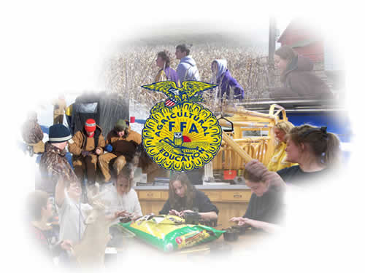

[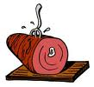](http://www1.free-clipart.net/gallery2/clipart/Food_And_Drink/Meats/Ham_-_Cartoon_1.jpg)